Name of the Student: G. Manasa | Academic Year: 2024-28
Student Registration Number: 241U1R3007 | Year & Term: II & I
Study Level: UG | Class & Section: CSE(DS)-IIA
Name of the Course: Start Up Management | Name of the Instructor: Meghana Bandi
Name of the Assessment: Mind Mapping | Date of Submission: 03-08-2025

Minimum Viable Product (MVP):

MVP stands for Minimum Viable Product. It is the first simple version of a product that has only the most important features. We build it quickly to test if the idea actually works in the real world. It helps us see if people will use and like the product or not.

Main Points I Understood:

Testing the idea early:

MVP helps us check if our idea is good before making the full product.

If people are not interested, we can stop early and save time and effort.

Better chance to get investors:

When we show a working MVP, it’s easier to prove our idea to investors.

They can see it working and may give money to improve it further.

Saves money and lowers risk:

We build only the basic parts first.

This means less money is spent and there’s less risk if something goes wrong.

Quick to build and launch:

Since it has only a few features, MVP is faster to make.

We can launch it early and start testing it with real users.

Get feedback from real users:

First users can try it and share their thoughts.

This helps us understand what to improve and what people like most.

Avoid big mistakes:

If the idea is not working, we can change direction early (this is called a pivot).

This helps us fix problems before wasting more time.

Make the product better with feedback:

After users try the MVP, we use their feedback to add or improve features.

It helps us build a smarter and more useful product.

Keeps the team focused:

The team only works on the main important features.

No time is wasted on building extra things that are not needed.

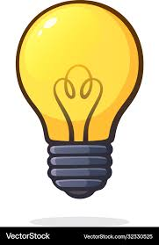
Hypothesis testing, validating the idea, ensuring market need


Mitigating lost investmentrisks and cutting development costs
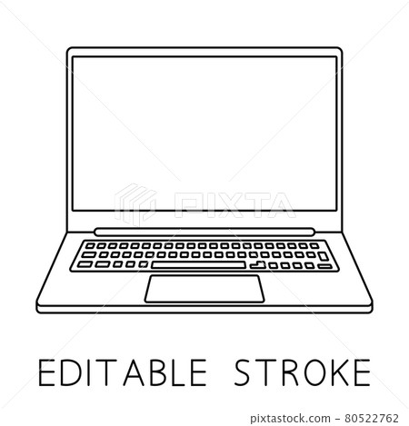
Freeing the team from useless work, better effort allocation


Higher chances to convince investors and get funding
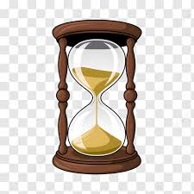
Accelerated development and quicker product release
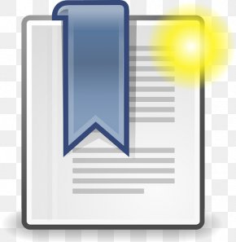v
Getting first traction, early adopters, and possibility profit
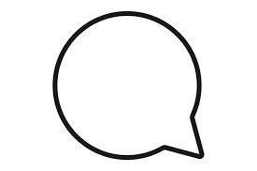
Building a better product based on customer feedback

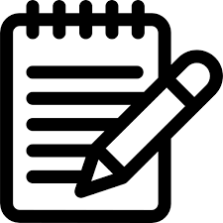
Dodging big strategy mistakes, discovering the need to pivot
Minimum viable product

Prototyping:
Prototyping means making a sample or rough model of a product or idea before building the real one. It’s like making a first draft to see how the product might look or work. This is not the final version, but it helps us and others understand the idea better. Prototyping saves time, money, and effort by helping us find and fix problems early.

Why Do We Need Prototyping?
Here are the main reasons we do prototyping:
- To see the design clearly:
  - It shows what the product will look like — like where the buttons are, how the screen looks, or how things are arranged.
- To explain the idea to others:
  - Sometimes, just talking about an idea isn’t enough. A prototype helps others see what we mean, whether it's our friends, teachers, or investors.
- To test if it’s easy to use:
  - We let people try the prototype and tell us if it’s easy or confusing. This helps improve the product early.
- To find mistakes early:
  - If something is wrong in the design, we can spot it early and fix it. This is better than finding mistakes after finishing everything.
- To save time and money:
  - If we build the full product and then find problems, it wastes effort. A prototype helps us test early and avoid that.

Types of Prototypes:
- Paper Prototypes:
Drawn on paper to show layout and design ideas.
- Wireframes:
Simple sketches (often digital) showing structure — like boxes and lines to plan screens.
- Clickable Prototypes:
A simple model where you can click buttons to see how it works (like using an app demo).
- Functional Prototypes:
A working version that has some real features, but not everything.

Steps in Prototyping:
- Start with an idea – What are we trying to make?
- Make a rough design – Use paper or a computer tool to plan it.
- Build a simple prototype – Use software or sketches to create a sample.
- Test with users or team – Ask others to try it out.
- Collect feedback – Listen to what they say and write it down.
- Improve the prototype – Make changes and test again if needed

Example: Milk Business


We will test if people really want doorstep milk delivery by launching a basic app.


We will avoid wasting money by building a simple app first before going big.

We will focus only on the most useful features and avoid wasting team effort.

A working MVP will help us attract local dairies or investors for funding.

We will launch faster with limited features to reach customers early.
v
We will start gaining users and earning small profits from the first version.

We will improve the app step-by-step as customers share their needs.

We will find out early if our plan needs to change based on real feedback.
Minimum viable product

